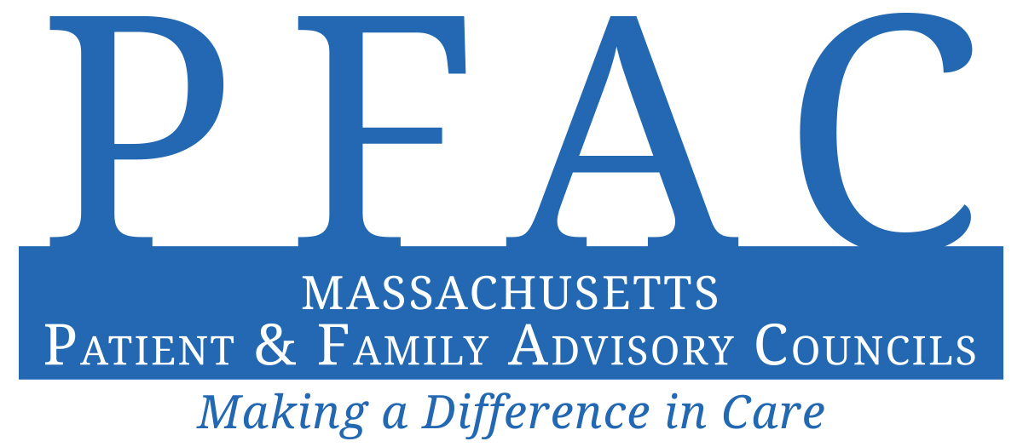
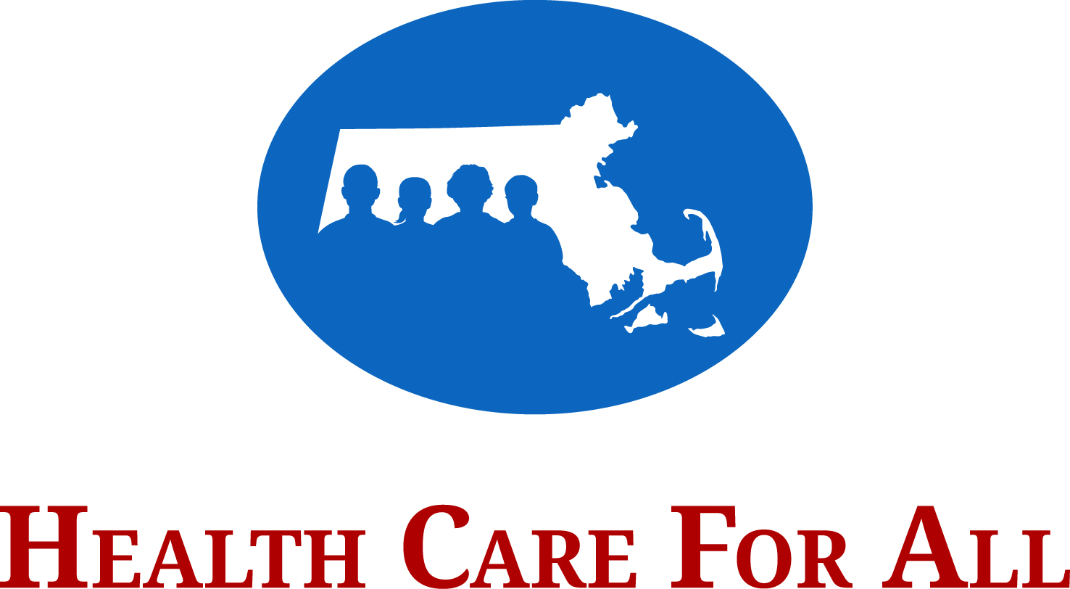

PFAC Annual Report Form

Health Care For All (HCFA) promotes health justice in Massachusetts by working to reduce disparities and ensure coverage and access for all. HCFA uses direct service, policy development, coalition building, community organizing, public education and outreach to achieve its mission. HCFA's vision is that everyone in Massachusetts has the equitable, affordable, and comprehensive care they need to be healthy.

Why complete an annual report for my PFAC?
Under Massachusetts law, hospital-wide PFACs are required to write annual reports by October 1st each year. These reports must be made available to members of the public upon request. As in past years, HCFA is requesting a copy of each report and submitted reports will be posted on HCFA’s website, www.hcfama.org. HCFA recommends using this template to assist with information collection, as well as the reporting of key activities and milestones.

What will happen with my report and how will HCFA use it?
We recognize the importance of sharing of information across PFACs. Each year, we
- make individual reports available online
- share the data so that PFACs can learn about what other groups are doing

Who can I contact with questions?
Please contact us at PFAC@hcfama.org or call us at 617-275-2982.

If you wish to use this Word document or any other form, please email it to PFAC@hcfama.org.
Reports should be completed by October 1, 2020.

2020 Patient and Family Advisory Council Annual Report Form
The survey questions concern PFAC activities in fiscal year 2020 only: (July 1, 2019 – June 30, 2020).

Section 1: General Information

1. Hospital Name: Spaulding Rehabilitation Hospital
NOTE: Massachusetts law requires every hospital to make a report about its PFAC publicly available. HCFA strongly encourages you to fill out a separate template for the hospital-wide PFAC at each individual hospital.
1a. Which best describes your PFAC?
☐ We are the only PFAC at a single hospital – skip to #3 below
☐ We are a PFAC for a system with several hospitals – skip to #2C below
☐ We are one of multiple PFACs at a single hospital
☒ We are one of several PFACs for a system with several hospitals – skip to #2C below
☐ Other (Please describe):
1b. Will another PFAC at your hospital also submit a report?
☐ Yes
☒ No
☐ Don’t know
1c. Will another hospital within your system also submit a report?
☒ Yes
☐ No
☐ Don’t know

3. Staff PFAC Co-Chair Contact:
2a. Name and Title: Sharon McLean, Quality and Compliance Manager
2b. Email: smclean2@partners.org
2c. Phone: 617-952-5312
☐ Not applicable

4. Patient/Family PFAC Co-Chair Contact:
3a. Name and Title: David Fischer
3b. Email: dbfischer22@gmail.com
3c. Phone:
☐ Not applicable

5. Is the Staff PFAC Co-Chair also the Staff PFAC Liaison/Coordinator?
☒ Yes – skip to #7 (Section 1) below
☐ No – describe below in #6

6. Staff PFAC Liaison/Coordinator Contact:
6a. Name and Title:
6b. Email:
6c. Phone:
☐ Not applicable

Section 2: PFAC Organization

7. This year, the PFAC recruited new members through the following approaches (check all that apply):
☒ Case managers/care coordinators
☐ Community based organizations
☐ Community events
☐ Facebook, Twitter, and other social media
☐ Hospital banners and posters
☐ Hospital publications
☐ Houses of worship/religious organizations
☐ Patient satisfaction surveys
☐ Promotional efforts within institution to patients or families
☐ Promotional efforts within institution to providers or staff
☒ Recruitment brochures
☒ Word of mouth/through existing members
☐ Other (Please describe):
☐ N/A – we did not recruit new members in FY 2020

8. Total number of staff members on the PFAC: 4

9. Total number of patient or family member advisors on the PFAC: 5

10. The name of the hospital department supporting the PFAC is: Quality and Compliance

11. The hospital position of the PFAC Staff Liaison/Coordinator is: Quality and Compliance Manager

12. The hospital provides the following for PFAC members to encourage their participation in meetings (check all that apply):
☐ Annual gifts of appreciation
☒ Assistive services for those with disabilities
☒ Conference call phone numbers or “virtual meeting” options
☐ Meetings outside 9am-5pm office hours
☒ Parking, mileage, or meals
☐ Payment for attendance at annual PFAC conference
☐ Payment for attendance at other conferences or trainings
☐ Provision/reimbursement for child care or elder care
☐ Stipends
☒ Translator or interpreter services
☐ Other (Please describe):
☐ N/A

Section 3: Community Representation

The PFAC regulations require that patient and family members in your PFAC be “representative of the community served by the hospital.” If you are not sure how to answer the following questions, contact your community relations office or check “don’t know.”

13. Our hospital’s catchment area is geographically defined as: Suffolk County
☐ Don’t know

14. Tell us about racial and ethnic groups in these areas (please provide percentages; if you are unsure of the percentages check “don’t know”):

 |  | RACE |  |  |  |  | ETHNICITY
 | %  American Indian or Alaska Native | %  Asian | %  Black or African American | %  Native Hawaiian or other Pacific Islander | %  White | %  Other | %  Hispanic, Latino, or Spanish origin
14a. Our defined catchment area |  | 9.3 | 24.7 |  | 61.5 |  | No comparable  data | ☐ Don’t know
14b. Patients the hospital provided care to in FY 2020 |  | 5.3 | 21.0 |  | 57.4 | 7.9 | 1.5 | ☐ Don’t know
14c. The PFAC patient and family advisors in FY 2020 |  |  |  |  | 100 |  |  | ☐ Don’t know

15. Tell us about languages spoken in these areas (please provide percentages; if you are unsure of the percentages select “don’t know”):

 | Limited English Proficiency (LEP) %
15a. Patients the hospital provided care to in FY 2020 |  | ☒ Don’t know
15b. PFAC patient and family advisors in FY 2020 | 0 | ☐ Don’t know

15c. What percentage of patients that the hospital provided care to in FY 2020 spoke the following as their primary language?
 | %
Spanish | 48
Portuguese | 10
Chinese | 13
Haitian Creole | 6
Vietnamese | 6
Russian | 2
French | 0
Mon-Khmer/Cambodian | 0
Italian | 1
Arabic | 13
Albanian | 0
Cape Verdean | 1
☐ Don’t know

15d. In FY 2020, what percentage of PFAC patient and family advisors spoke the following as their primary language?
 | %
Spanish | 0
Portuguese | 0
Chinese | 0
Haitian Creole | 0
Vietnamese | 0
Russian | 0
French | 0
Mon-Khmer/Cambodian | 0
Italian | 0
Arabic | 0
Albanian | 0
Cape Verdean | 0
☐ Don’t know

16. The PFAC is undertaking the following activities to ensure appropriate representation of our membership in comparison to our patient population or catchment area:
Development of recruitment strategies that will reach all programs (Stroke, Brain Injury, Spinal cord Injury, Complex Rehab, Pediatrics) from both inpatient and outpatient settings, as well as across various demographics (male/female, all age groups, various ethnic groups).

Section 4: PFAC Operations

17. Our process for developing and distributing agendas for the PFAC meetings (choose):
☐ Staff develops the agenda and sends it out prior to the meeting
☐ Staff develops the agenda and distributes it at the meeting
☐ PFAC members develop the agenda and send it out prior to the meeting
☐ PFAC members develop the agenda and distribute it at the meeting
☐ PFAC members and staff develop agenda together and send it out prior to the meeting. (Please describe below in #17a)
☒ PFAC members and staff develop agenda together and distribute it at the meeting. (Please describe below in #17a)
☐ Other process (Please describe below in #17b)
☐ N/A – the PFAC does not use agendas

17a. If staff and PFAC members develop the agenda together, please describe the process:
Agenda topics from staff and patient/family members are generated and their priority discussed on an ongoing basis. Prior to each meeting, co-chairs review the previous meeting minutes and finalize the upcoming meeting agenda.

17b. If other process, please describe:

18. The PFAC goals and objectives for 2020 were: (check the best choice):
☐ Developed by staff alone
☐ Developed by staff and reviewed by PFAC members
☒ Developed by PFAC members and staff
☐ N/A – we did not have goals for FY 2020– Skip to #20

19. The PFAC had the following goals and objectives for 2020:
- Review/revision of the PFAC charter
- Educate PFAC members on concepts of patient- and family-centered care
- Development of recruitment strategies that involves current PFAC members
- Increase request form hospital staff & committees for PFAC involvement in projects/initiatives

20. Please list any subcommittees that your PFAC has established:

21. How does the PFAC interact with the hospital Board of Directors (check all that apply):
☒ PFAC submits annual report to Board
☐ PFAC submits meeting minutes to Board
☐ Action items or concerns are part of an ongoing “Feedback Loop” to the Board
☐ PFAC member(s) attend(s) Board meetings
☐ Board member(s) attend(s) PFAC meetings
☐ PFAC member(s) are on board-level committee(s)
☐ Other (Please describe):
☐ N/A – the PFAC does not interact with the Hospital Board of Directors

22. Describe the PFAC’s use of email, listservs, or social media for communication:
Email is used to communicate with members – including agenda, meeting materials, and meeting reminders and announcements.
☐ N/A – We don’t communicate through these approaches

Section 5: Orientation and Continuing Education

23. Number of new PFAC members this year: 2

24. Orientation content included (check all that apply):
☐ “Buddy program” with experienced members
☐ Check-in or follow-up after the orientation
☒ Concepts of patient- and family-centered care (PFCC)
☒ General hospital orientation
☐ Health care quality and safety
☒ History of the PFAC
☒ Hospital performance information
☐ Immediate “assignments” to participate in PFAC work
☒ Information on how PFAC fits within the organization’s structure
☐ In-person training
☒ Massachusetts law and PFACs
☐ Meeting with hospital staff
☐ Patient engagement in research
☒ PFAC policies, member roles and responsibilities
☐ Skills training on communication, technology, and meeting preparation
☐ Other (Please describe below in #24a)
☐ N/A – the PFAC members do not go through a formal orientation process

24a. If other, describe:

25. The PFAC received training on the following topics:
☒ Concepts of patient- and family-centered care (PFCC)
☐ Health care quality and safety measurement
☐ Health literacy
☐ A high-profile quality issue in the news in relation to the hospital (e.g. simultaneous surgeries, treatment of VIP patients, mental/behavioral health patient discharge, etc.)
☐ Hospital performance information
☐ Patient engagement in research
☐ Types of research conducted in the hospital
☐ Other (Please describe below in #25a)
☐ N/A – the PFAC did not receive training

25a. If other, describe:

Section 6: FY 2020 PFAC Impact and Accomplishments
The following information only concerns PFAC activities in the fiscal year 2020.

26. Please share the following information on the PFACs accomplishments and impacts:

26a. What were the three greatest accomplishments/impacts of the PFAC related to providing feedback or perspective?
Accomplishment/Impact | Idea came from (choose one)
Accomplishment/Impact 1:  Evaluated and provided feedback to our Chief Learning officer regarding new pillow speakers for patient rooms. | ☐ Patient/family advisors of the PFAC  ☒ Department, committee, or unit that requested PFAC input
Accomplishment/Impact 2:  Improved members understanding and ability to provide valuable patient-centered feedback & perspective by educating them on initiatives such as Patient Experience Week and What Matters to You Day. | ☒ Patient/family advisors of the PFAC  ☐ Department, committee, or unit that requested PFAC input
Accomplishment/Impact 3:  By reviewing/revising our PFAC Charter and Confidentiality Agreement, our members gained a better understanding of their role & responsibilities when providing feedback to Hospital staff. | ☐ Patient/family advisors of the PFAC  ☒ Department, committee, or unit that requested PFAC input

26b. What were the three greatest accomplishments/impacts of the PFAC related to influencing the institution’s financial and programmatic decisions?

Accomplishment/Impact | Idea came from (choose one)
Accomplishment/Impact 1:  Revised our PFAC informational pamphlet and created a system for the pamphlets to be displayed and replaced, when needed, in the family lounges of each inpatient program. | ☒ Patient/family advisors of the PFAC  ☐ Department, committee, or unit that requested PFAC input
Accomplishment/Impact 2: | ☐ Patient/family advisors of the PFAC  ☐ Department, committee, or unit that requested PFAC input
Accomplishment/Impact 3: | ☐ Patient/family advisors of the PFAC  ☐ Department, committee, or unit that requested PFAC input

26c. What were the three greatest accomplishments/impacts of the PFAC related leading/co-leading programs and initiatives?
Accomplishment/Impact | Idea came from (choose one)
Accomplishment/Impact 1:  Development of Patient Experience Week activities PFAC members would participate in to increase exposure and recruit new members (example: information tables, speakers at Dept meetings, etc). | ☒ Patient/family advisors of the PFAC  ☐ Department, committee, or unit that requested PFAC input
Accomplishment/Impact 2: | ☐ Patient/family advisors of the PFAC  ☐ Department, committee, or unit that requested PFAC input
Accomplishment/Impact 3: | ☐ Patient/family advisors of the PFAC  ☐ Department, committee, or unit that requested PFAC input

27. The five greatest challenges the PFAC had in FY 2020:
Challenge 1: The COVID Pandemic limited our in-person meetings and planned recruitment initiatives.
Challenge 2: Limited requests from Hospital staff/committees for PFAC involvement in
projects/initiatives.
Challenge 3: Recruitment of new patient/family members
Challenge 4: Staff turnover
Challenge 5:
☐ N/A – we did not encounter any challenges in FY 2020

28. The PFAC members serve on the following hospital-wide committees, projects, task forces, work groups, or Board committees:
☐ Behavioral Health/Substance Use
☐ Bereavement
☐ Board of Directors
☐ Care Transitions
☐ Code of Conduct
☐ Community Benefits
☐ Critical Care
☐ Culturally Competent Care
☐ Discharge Delays
☐ Diversity & Inclusion
☐ Drug Shortage
☐ Eliminating Preventable Harm
☐ Emergency Department Patient/Family Experience Improvement
☐ Ethics
☐ Institutional Review Board (IRB)
☐ Lesbian, Gay, Bisexual, and Transgender (LGBT) – Sensitive Care
☐ Patient Care Assessment
☐ Patient Education
☒ Patient and Family Experience Improvement
☐ Pharmacy Discharge Script Program
☐ Quality and Safety
☐ Quality/Performance Improvement
☐ Surgical Home
☐ Other (Please describe):
☐ N/A – the PFAC members do not serve on these – Skip to #30

29. How do members on these hospital-wide committees or projects report back to the PFAC about their work?
As needed reporting during general updates or as an agenda item, if additional time is needed.

30. The PFAC provided advice or recommendations to the hospital on the following areas mentioned in the Massachusetts law (check all that apply):
☐ Institutional Review Boards
☐ Patient and provider relationships
☐ Patient education on safety and quality matters
☒ Quality improvement initiatives
☐ N/A – the PFAC did not provide advice or recommendations to the hospital on these areas in FY 2020

31. PFAC members participated in the following activities mentioned in the Massachusetts law (check all that apply):
☐ Advisory boards/groups or panels
☐ Award committees
☐ Co-trainers for clinical and nonclinical staff, in-service programs, and health professional trainees
☐ Search committees and in the hiring of new staff
☐ Selection of reward and recognition programs
☐ Standing hospital committees that address quality
☐ Task forces
☒ N/A – the PFAC members did not participate in any of these activities

32. The hospital shared the following public hospital performance information with the PFAC (check all that apply):
32a. Complaints and serious events
☐ Complaints and investigations reported to Department of Public Health (DPH)
☐ Healthcare-Associated Infections (National Healthcare Safety Network)
☐ Patient complaints to hospital
☐ Serious Reportable Events reported to Department of Public Health (DPH)

32b. Quality of care
☐ High-risk surgeries (such as aortic valve replacement, pancreatic resection)
☐ Joint Commission Accreditation Quality Report (such as asthma care, immunization, stroke care)
☐ Medicare Hospital Compare (such as complications, readmissions, medical imaging)
☐ Maternity care (such as C-sections, high risk deliveries)

32c. Resource use, patient satisfaction, and other
☐ Inpatient care management (such as electronically ordering medicine, specially trained doctors for ICU patients)
☐ Patient experience/satisfaction scores (eg. HCAHPS - Hospital Consumer Assessment of Healthcare Providers and Systems)
☐ Resource use (such as length of stay, readmissions)
☐ Other (Please describe):
☒ N/A – the hospital did not share performance information with the PFAC – Skip to #35

33. Please explain why the hospital shared only the data you checked in Q 32 above:

34. Please describe how the PFAC was engaged in discussions around these data in #32 above and any resulting quality improvement initiatives:

35. The PFAC participated in activities related to the following state or national quality of care initiatives (check all that apply):
35a. National Patient Safety Hospital Goals
☐ Identifying patient safety risks
☐ Identifying patients correctly
☐ Preventing infection
☐ Preventing mistakes in surgery
☐ Using medicines safely
☐ Using alarms safely

35b. Prevention and errors
☐ Care transitions (e.g., discharge planning, passports, care coordination, and follow up between care settings)
☐ Checklists
☐ Electronic Health Records –related errors
☐ Hand-washing initiatives
☐ Human Factors Engineering
☐ Fall prevention
☐ Team training
☐ Safety

35c. Decision-making and advanced planning
☐ End of life planning (e.g., hospice, palliative, advanced directives)
☐ Health care proxies
☒ Improving information for patients and families
☐ Informed decision making/informed consent

35d. Other quality initiatives
☐ Disclosure of harm and apology
☐ Integration of behavioral health care
☐ Rapid response teams
☐ Other (Please describe):
☐ N/A – the PFAC did not work in quality of care initiatives

36. Were any members of your PFAC engaged in advising on research studies?
☐ Yes
☒ No – Skip to #40 (Section 6)

37. In what ways are members of your PFAC engaged in advising on research studies? Are they:
☐ Educated about the types of research being conducted
☐ Involved in study planning and design
☐ Involved in conducting and implementing studies
☐ Involved in advising on plans to disseminate study findings and to ensure that findings are communicated in understandable, usable ways
☐ Involved in policy decisions about how hospital researchers engage with the PFAC (e.g. they work on a policy that says researchers have to include the PFAC in planning and design for every study)

38. How are members of your PFAC approached about advising on research studies?
☐ Researchers contact the PFAC
☐ Researchers contact individual members, who report back to the PFAC
☐ Other (Please describe below in #38a)
☐ None of our members are involved in research studies

38a. If other, describe:

39. About how many studies have your PFAC members advised on?
☐ 1 or 2
☐ 3-5
☐ More than 5
☐ None of our members are involved in research studies

Section 7: PFAC Annual Report
We strongly suggest that all PFAC members approve reports prior to submission.

40. The following individuals approved this report prior to submission (list name and indicate whether staff or patient/family advisor):
Staff: Sharon Mclean
Patient/Family: Brian Bassett, Dave Fischer, Murray Mazer, Susan Bottary

41. Describe the process by which this PFAC report was completed and approved at your institution (choose the best option).
☐ Collaborative process: staff and PFAC members both wrote and/or edited the report
☒ Staff wrote report and PFAC members reviewed it
☐ Staff wrote report
☐ Other (Please describe):

Massachusetts law requires that each hospital’s annual PFAC report be made available to the public upon request. Answer the following questions about the report:
42. We post the report online.
☒ Yes, link: https://spauldingrehab.org/about/pfac
☐ No

43. We provide a phone number or e-mail address on our website to use for requesting the report.
☒ Yes, phone number/e-mail address: Sharon McLean | smclean2@partners.org | 617-952-5312
☐ No

44. Our hospital has a link on its website to a PFAC page.
☒ Yes, link: https://spauldingrehab.org/about/pfac
☐ No, we don’t have such a section on our website

