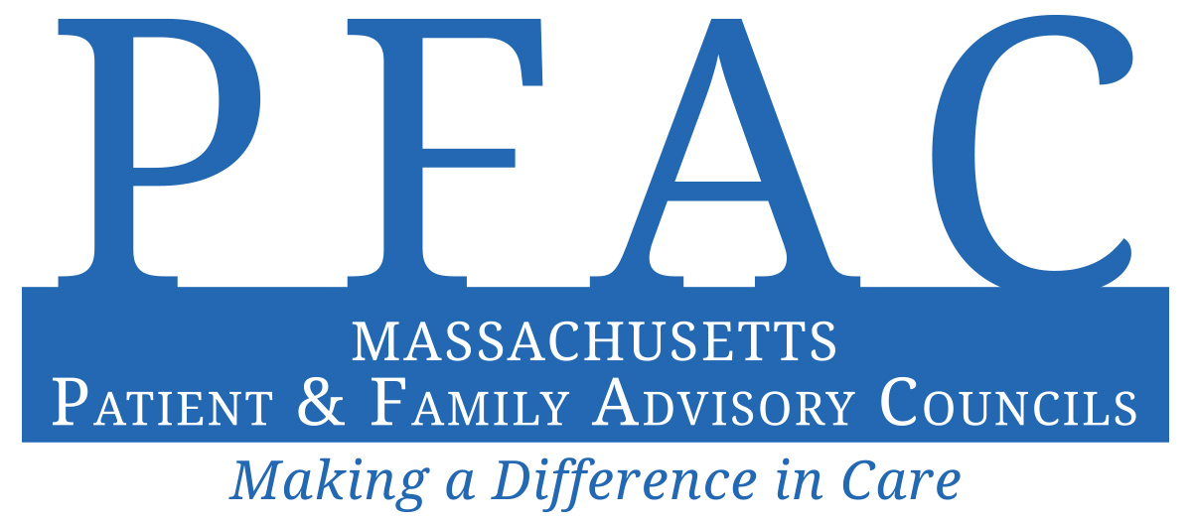
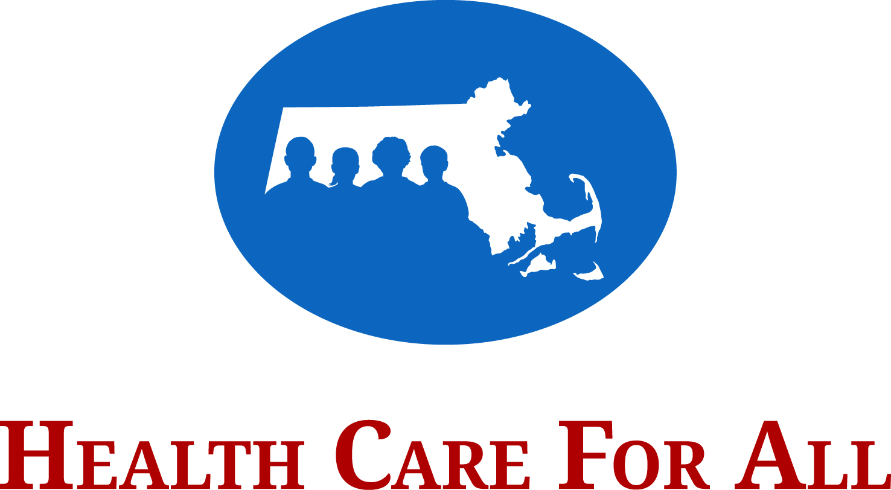

PFAC Annual Report Form

Health Care For All (HCFA) promotes health justice in Massachusetts by working to reduce disparities and ensure coverage and access for all. HCFA uses direct service, policy development, coalition building, community organizing, public education and outreach to achieve its mission. HCFA's vision is that everyone in Massachusetts has the equitable, affordable, and comprehensive care they need to be healthy.

Why complete an annual report for my PFAC?
Under Massachusetts law, hospital-wide PFACs are required to write annual reports by October 1st each year. These reports must be made available to members of the public upon request. As in past years, HCFA is requesting a copy of each report and submitted reports will be posted on HCFA’s website, www.hcfama.org. HCFA recommends using this template to assist with information collection, as well as the reporting of key activities and milestones.

What will happen with my report and how will HCFA use it?
We recognize the importance of sharing of information across PFACs. Each year, we
- make individual reports available online
- share the data so that PFACs can learn about what other groups are doing

Who can I contact with questions?
Please contact us at PFAC@hcfama.org or call us at 617-275-2982.

If you wish to use this Word document or any other form, please email it to PFAC@hcfama.org.
Reports should be completed by October 1, 2019.

2019 Patient and Family Advisory Council Annual Report Form

The survey questions concern PFAC activities in fiscal year 2020 only: (July 1, 2019 – June 30, 2020).

Section 1: General Information
1. Hospital Name: Cambridge Health Alliance (CHA)

NOTE: Massachusetts law requires every hospital to make a report about its PFAC publicly available. HCFA strongly encourages you to fill out a separate template for the hospital-wide PFAC at each individual hospital.

2a. Which best describes your PFAC?
☐ We are the only PFAC at a single hospital – skip to #3 below
☒ We are a PFAC for a system with several hospitals – skip to #2C below
☐ We are one of multiple PFACs at a single hospital
☐ We are one of several PFACs for a system with several hospitals – skip to #2C below
☐ Other (Please describe):

2b. Will another PFAC at your hospital also submit a report?
☐ Yes
☒ No
☐ Don’t know

2c. Will another hospital within your system also submit a report?
☐ Yes
☒ No
☐ Don’t know

3. Staff PFAC Co-Chair Contact:
2a. Name and Title: Mary Cassesso, Foundation President & Chief Community Officer
Sarah Primeau, Community Relations Manager
2b. Email: mcassesso@challiance.org
sprimeau@challiance.org
2c. Phone: 617-591-4947

4. Patient/Family PFAC Co-Chair Contact:
3a. Name and Title: Barbara August
3b. Email: barbaralaugust@hotmail.com
3c. Phone: 617-852-5109

5. Is the Staff PFAC Co-Chair also the Staff PFAC Liaison/Coordinator?
☒ Yes – skip to #7 (Section 1) below
☐ No – describe below in #6

6. Staff PFAC Liaison/Coordinator Contact:
6a. Name and Title:
6b. Email:

6c. Phone:

Section 2: PFAC Organization
7. This year, the PFAC recruited new members through the following approaches (check all that apply):
☒ Case managers/care coordinators
☐ Community based organizations
☐ Community events
☒ Facebook, Twitter, and other social media
☒ Hospital banners and posters
☒ Hospital publications
☐ Houses of worship/religious organizations
☒ Patient satisfaction surveys
☒ Promotional efforts within institution to patients or families
☒ Promotional efforts within institution to providers or staff
☒ Recruitment brochures
☐ Word of mouth/through existing members
☒ Other (Please describe): Primary Care Doctors
☐ N/A – we did not recruit new members in FY 2018

8. Total number of staff members on the PFAC: 9
9. Total number of patient or family member advisors on the PFAC: 10
10. The name of the hospital department supporting the PFAC is: Community Relations Office/Executive Offices
11. The hospital position of the PFAC Staff Liaison/Coordinator is: Community Relations Program Manager
12. The hospital provides the following for PFAC members to encourage their participation in meetings (check all that apply):
☒ Annual gifts of appreciation
☐ Assistive services for those with disabilities
☒ Conference call phone numbers or “virtual meeting” options
☒ Meetings outside 9am-5pm office hours
☒ Parking, mileage, or meals
☐ Payment for attendance at annual PFAC conference
☒ Payment for attendance at other conferences or trainings
☐ Provision/reimbursement for child care or elder care
☐ Stipends
☒ Translator or interpreter services (if needed)
☐ Other (Please describe):
Section 3: Community Representation

The PFAC regulations require that patient and family members in your PFAC be “representative of the community served by the hospital.” If you are not sure how to answer the following questions, contact your community relations office or check “don’t know.”

13. Our hospital’s catchment area is geographically defined as: Cambridge, Somerville & Metro-north (Malden/Medford/Chelsea/Revere/Everett/Winthrop)
Cambridge Health Alliance (CHA) is a regional safety net health system committed to providing high quality care to diverse and low-income populations from eight urban cities north and west of Boston, MA. CHA has two hospitals in Cambridge and Everett, one campus in Somerville that includes an urgent care center, as well as 15 neighborhood health centers and primary care practices throughout Somerville, Cambridge, Everett, Malden, and Revere

14. Tell us about racial and ethnic groups in these areas (please provide percentages; if you are unsure of the percentages check “don’t know”):
As the sole public hospital in Massachusetts, CHA serves as a safety net for nearly 140,000 of the state’s most vulnerable and diverse patients. Approximately 70% of CHA patients are low-income, disabled, elderly or uninsured. CHA’s primary service area has a high percentage of residents living below the federal poverty level (13-28% cf. to the state average of 11.6%) and serves a diverse patient population (see below). CHA has a longstanding commitment to vulnerable and diverse patients and is proud to serve all those in need. Its motto is "We Care for All."

Many CHA patients have public or subsidized insurance (Medicare, Medicaid, etc.) and traditionally experience barriers to care. In order to serve these individuals and families, CHA has bilingual providers, a robust interpreter program and numerous linguistic services. It also has an award-winning Volunteer Health Advisor program that brings together people from many cultures to help local residents gain access to care and live healthier lives.

 |  | RACE |  |  |  |  | ETHNICITY
 | %  American Indian or Alaska Native | %  Asian | %  Black or African American | %  Native Hawaiian or other Pacific Islander | %  White | %  Other | %  Hispanic, Latino, or Spanish origin
14a. Our defined catchment area | 0.0% | 10.6% | 8.9% | 0.0% | 60.8% | 3.7% | 16%
14b. Patients the hospital provided care to in FY 2020 | 1.0% | 10.0% | 17.0% | 0.0% | 38.0% | 34.0% | 14.5%
14c. The PFAC patient and family advisors in FY 2020 | 0.0% | 20% | 10% | 0.0% | 70% | 0% | 0%

15. Tell us about languages spoken in these areas (please provide percentages; if you are unsure of the percentages select “don’t know”):

Cambridge Health Alliance serves one of the most culturally and linguistically diverse patient populations in the United States. Over half our patients speak a language other than English at home. Around 44% of our primary care patients have limited English proficiency and need a professional medical interpreter.

Limited English Proficiency (LEP)
%
15a. Patients the hospital provided care to in FY 2020 | 43% | ☐ Don’t  know
15b. PFAC patient and family advisors in FY 2020 | 10% | ☐ Don’t  know

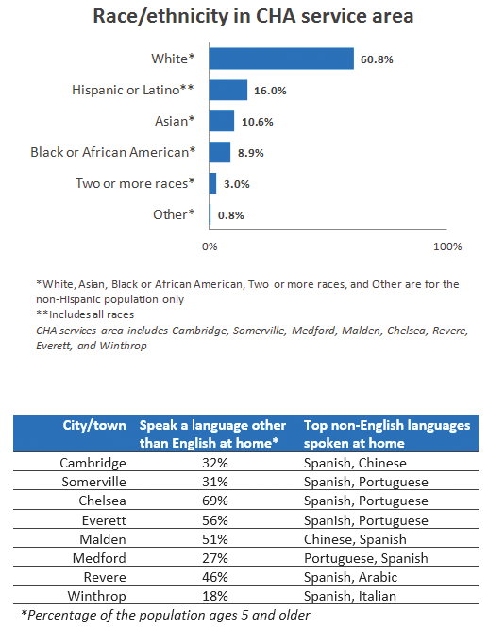

15c. What percentage of patients that the hospital provided care to in FY 2020 spoke the following as their primary language?
 | %
Spanish | 13%
Portuguese | 15%
Chinese | 2%
Haitian Creole | 6%
Vietnamese | 2%
Russian | 0%
French | 0%
Mon-Khmer/Cambodian | 0%
Italian | 0%
Arabic | 1.1%
Albanian | 0%
Cape Verdean | 0%
Hindi | 1%

15d. In FY 2020, what percentage of PFAC patient and family advisors spoke the following as their primary language?
 | %
Spanish | 0.0%
Portuguese | 0.0%
Chinese | 0.0%
Haitian Creole | 0.0%
Vietnamese | 0.0%
Russian | 0.0%
French | 0.0%
Mon-Khmer/Cambodian | 0.0%
Italian | 0.0%
Arabic | 0.0%
Albanian | 0.0%
Cape Verdean | 0.0%
Hindi | 10%

16. The PFAC is undertaking the following activities to ensure appropriate representation of our membership in comparison to our patient population or catchment area:

At CHA we actively seek to bring on new PFAC members from different backgrounds that represent the communities and patients in which we serve. We have had success this year in recruiting patients to the PFAC who reflect the patient population served by our entire system. However, we continue to aspire to get patients who represent the diversity of our community. Many CHA patients have public or subsidized insurance (Medicare, Medicaid, etc.) and traditionally experience barriers to care, therefore, it can be difficult recruiting these patients to serve on a volunteer committee. We try to relieve barriers by providing transportation/reimbursement, a free meal at every meeting as well as the option to join virtually through Google Meet or phone dial-in. There is still work to be done and we plan to strengthen recruitment efforts at our care centers and specifically target populations that we know are engaged in care but not currently serving on our PFAC (e.g. Muslim/Arabic/Haitian-Creole/LatinX patients). In order to do this, we will continue working directly with the medical team to help us identify patients of these different backgrounds who they consider good fits for the PFAC. This year we recruited 1 new patient who is serving on the PFAC.

Section 4: PFAC Operations
17. Our process for developing and distributing agendas for the PFAC meetings (choose):
☐ Staff develops the agenda and sends it out prior to the meeting
☐ Staff develops the agenda and distributes it at the meeting
☐ PFAC members develop the agenda and send it out prior to the meeting
☐ PFAC members develop the agenda and distribute it at the meeting
☒ PFAC members and staff develop agenda together and send it out prior to the meeting. (Please describe below in #17a)
☐ PFAC members and staff develop agenda together and distribute it at the meeting. (Please describe below in #17a)
☐ Other process (Please describe below in #17b)
☐ N/A – the PFAC does not use agendas

17a. If staff and PFAC members develop the agenda together, please describe the process:

At every meeting we end with a discussion of next steps and plans for future meetings. We often use this discussion to guide the development of the agenda for the following months meeting. Approximately a week before the scheduled PFAC meeting, the staff co-chairs edit and finalize the agenda and then email it to the PFAC. Members are given the opportunity to make additions/edits. Printed copies of the agenda are distributed during the actual meeting. Since COVID-19’s beginnings in March, meetings became virtual and agendas and materials are distributed through email.

17b. If other process, please describe:

18. The PFAC goals and objectives for 20120 were: (check the best choice):
☐ Developed by staff alone
☐ Developed by staff and reviewed by PFAC members
☒ Developed by PFAC members and staff
☐ N/A – we did not have goals for FY 2019– Skip to #20

19. The PFAC had the following goals and objectives for FY2020:

- Increase recruitment of patient members
Last year we were successful in recruiting several new patient members to the CHA PFAC. Since this is a volunteer position, retention of patients can be difficult and therefore we need to be proactive in recruiting new members to fill spaces of outgoing members. We were successful in recruiting 3 new members in FY2020 and for FY2021 we would like to see expansion in this recruitment effort and campaign. Special emphasis will be placed on recruiting patients that reflect our diverse patient population.
- Improved integration into the CHA system
Our continued goal for FY2020 was to further improve our visibility within the system. The PFAC will strive to work closer with various CHA departments and be in attendance at community and CHA events. In addition, we wanted to continue to increase the amount of interaction and communication between the PFAC and the CHA Quality Committee of the Board of Trustees.

Prior to the submission of this report the PFAC discussed goals for FY21 which include the following:
- Input into COVID-19 information and educational materials that will be disseminated to patients and community members.

- Access to Care: The PFAC would like to try to work on more projects and initiatives focused on accessibility to health care. Both in terms of easier access to CHA services, but also how we can bring “care to the people” in the communities where they live. We know that for vulnerable populations, barriers exist and accessing care when it is needed most can be difficult. The PFAC would like to collaborate with other departments and our city’s health departments to expand on the access work already being done within the system.

- Social/Racial Justice & Health Equity: The COVID-19 pandemic has shone a light on health disparities among low-income and minority populations, many of whom are CHA patients and make up our “essential” workforce and have kept this country going in such an arduous time. At CHA, we care for all and the PFAC and the entire CHA system are reflecting on ways to support racial and social justice both internally and in our communities. The PFAC has already provided input into the Massachusetts Legislature’s Health Disparities Task Force (where our CEO is co-chair along with 12 other experts and state legislators). We have many internal groups working on this issue and the PFAC would like to play a larger role in this as well.

- Improve PFAC webpage. We initially created a PFAC webpage a few years ago and it is out of date and there are many opportunities for improvement. PFAC members would like to see biographies for each

member on the webpage as well as well as recent and on-going projects that the PFAC has/is contributing to.

20. Please list any subcommittees that your PFAC has established:
As described in our FY2019 report, CHA has an ACO-PFAC which is comprised of a subset of PFAC members who are members of the CHA-wide PFAC and have MassHealth insurance products. This year we decided to roll both meetings into one while extending the meeting time, since the vast majority of the topics for ACO specific issues are also of interest to the entire PFAC. ACO PFAC summary charter and key responsibilities include: Advising the ACO Governing Board as to Member/family perspectives regarding ACO services, quality, safety and care delivery; developing a deeper understanding of how we are and are not partnering with patients for improvement and health, and strategizing how to optimize this partnership; and providing feedback and recommendations related to the impact of social determinants, including the potential impact of these factors on key populations served by the ACPP (e.g. Members with disabilities, those requiring long-term supports and services (LTSS) and/or those with behavioral health (BH) needs).

We also have a small group of patients and staff who work on a committee solely focused on the CHA Malden Family Health Care Center. PFAC staff attend these meetings and staff from the Malden group also attend the PFAC meetings as often as possible to encourage system-wide collaboration.

21. How does the PFAC interact with the hospital Board of Directors (check all that apply):
☐ PFAC submits annual report to Board
☐ PFAC submits meeting minutes to Board
☐ Action items or concerns are part of an ongoing “Feedback Loop” to the Board
☐ PFAC member(s) attend(s) Board meetings
☐ Board member(s) attend(s) PFAC meetings
☐ PFAC member(s) are on board-level committee(s)
☒ Other (Please describe): PFAC highlights are sent to the Chief of Staff at CHA and are included in departmental update reports to the Board of Trustees as necessary.
☐ N/A – the PFAC does not interact with the Hospital Board of Directors

22. Describe the PFAC’s use of email, listservs, or social media for communication:
The CHA PFAC primarily communicates through email between monthly in-person meetings. On occasion, when a department request requires a fast turnaround, emails and/or additional meetings may be sent and arranged. Most frequently, documents are sent by email to patient members to solicit their feedback.
This past year, CHA’s Marketing Department helped us continue to expand the PFAC’s social media presence and we are able to feature PFAC activities and contributions on Instagram and Facebook.

Section 5: Orientation and Continuing Education
23. Number of new PFAC members this year: 1

24. Orientation content included (check all that apply):
☐ “Buddy program” with experienced members
☐ Check-in or follow-up after the orientation
☒ Concepts of patient- and family-centered care (PFCC)
☐ General hospital orientation
☒ Health care quality and safety
☒ History of the PFAC
☒ Hospital performance information
☐ Immediate “assignments” to participate in PFAC work
☒ Information on how PFAC fits within the organization’s structure
☐ In-person training
☒ Massachusetts law and PFACs
☒ Meeting with hospital staff
☐ Patient engagement in research
☒ PFAC policies, member roles and responsibilities
☐ Skills training on communication, technology, and meeting preparation
☐ Other (Please describe below in #24a)
☐ N/A – the PFAC members do not go through a formal orientation process

24a. If other, describe:

25. The PFAC received training on the following topics:
☐ Concepts of patient- and family-centered care (PFCC)
☒ Health care quality and safety measurement
☐ Health literacy
☒ A high-profile quality issue in the news in relation to the hospital (e.g. simultaneous surgeries, treatment of VIP patients, mental/behavioral health patient discharge, etc.)
☐ Hospital performance information
☐ Patient engagement in research
☐ Types of research conducted in the hospital
☐ Other (Please describe below in #25a)
☐ N/A – the PFAC did not receive training

Section 6: FY 2019 PFAC Impact and Accomplishments
The following information only concerns PFAC activities in the fiscal year 2020.

26. The greatest accomplishments of the PFAC were:

FY20
Accomplishment | Idea came from (choose one) | PFAC role can be best described as (choose one)
26a. Accomplishment 1:  Increased presence and integration at CHA:  An on-going goal of the PFAC over the past few years has been to continue to garner support and visibility of the PFAC throughout all of CHA. Since CHA has two hospitals, a campus in Somerville, and 15 care centers, it can be difficult to get information to everyone as needed. We are a large system and have been working to make the PFAC known as a resource to everyone. This past year the PFAC was asked to support work being done in many departments and has become known as a valued resource when patient voice and input are needed. In FY2020, the PFAC expanded its role by supporting more departments than ever before with critical feedback on the patient experience. The council provided guidance and input into work in the following areas:  - COVID-19 CHA response and access to care  - The State Legislature’s Health Equity Task Force  - MyCHART improvements  - 21st Century Cures Act  - Emergency Department change to Urgent Care Center at the CHA Somerville Hospital  - Educational materials on the topic of levels of care (primary/urgent/emergency etc.).  - Procurement & hand making PPE during COVID-19 height in March/April/May  - Psychiatry services  - Complex care management survey  - Social Determinants of Health (SDOH) Screening tool  - Gold Foundation project feedback  - Pharmacy & patient prescriptions and experience  - Press Ganey surveys  - Emergency Department and satisfaction surveys/feedback  - New CEO search  - Branding & Marketing  - Population health video input  - CHA services & priorities in Somerville  This year, several PFAC members continued to hold seats on other CHA committees. This was an intentional decision brought forth by the committees in order to bring the patient voice to the decision-making table. A PFAC patient member participated in the Patient Safety Committee (PSC). The PSC looks at adverse events at CHA and they look into what we can do to improve or prevent these events from happening again. The strong focus is on quality and quality improvement.  Another PFAC member participates on the Patient Care Improvement Committee (PCIC). There are spectrums of care at CHA and the  PCIC is more focused on smaller improvements rather than larger, more adverse issues like the Patient Safety Committee. This committee focuses on ways to improve the patient experience in every aspect of their contact with the system. | ☒ Patient/family advisors of the PFAC  ☒ Department, committee, or unit that requested PFAC input | ☒ Being informed about topic  ☒ Providing feedback or perspective  ☒ Discussing and influencing decisions/agenda  ☐ Leading/co leading
26a. Accomplishment 2:  Recruitment:  As in past years, an on-going PFAC goal is to recruit new members to the council. This includes new patients/families as well as staff from within the system. Over the past few years we have had stable patient/family membership - with patient/family members holding the majority of seats on the council. This year we recruited 1 additional patient. We had 3 patients in total who were interested in joining the PFAC, but due to work schedules changing and not being able to commit to regularly attend meetings, 2 of them decided to hold-off from joining at that time.  Recruitment activities this year were primarily through social media/online portal as well as word of mouth.  Moving forward we hope to utilize more direct provider recommendations. | ☒ Patient/family advisors of the PFAC  ☐ Department, committee, or unit that requested PFAC input | ☐ Being informed about topic  ☐ Providing feedback or perspective  ☐ Discussing and influencing decisions/agenda  ☒ Leading/co leading

27. The greatest challenges the PFAC had in FY 2020:

27a. Challenge 1:
Time & Demand:
Time management has remained a challenge for our PFAC. It is not an issue of planning, but more an issue of demand. As the PFAC gains visibility throughout the system, we receive more requests for patient input and often have more demand than time to get through every request. What may be needed is building time for work in between regularly scheduled monthly meetings. It can be difficult to keep members engaged particularly with projects and programming between meetings, but this is something we can try to dedicate more time and planning for.

27b. Challenge 2:
Recruitment of patients who represent the patient population:
We will continue with recruitment efforts in FY21 and specifically target our MCREW (Malden/Medford, Chelsea, Revere, Everett, and Winthrop) communities for new members. At this time our committee is still heavily Somerville/Cambridge-centric and we would like to diversify geographical membership as much as possible. Now that we have increased communication and collaboration between the PFAC and the smaller patient group at our Malden clinic, we have been able to include more patient voice from the Malden community. At CHA we care for people from all backgrounds and have a particular strength in caring for patients with economic, linguistic and cultural barriers to care. That said, it has been extremely difficult to get these particular populations engaged with the PFAC. We do plan to continue outreach to these populations and hope we are able to diversify the council even further into the coming year.

27c. Challenge 3:
Cyclical Feedback:
Something we have not focused as much on is getting results and information back from the staff who asked for PFAC input. It is really important in the process to take the time and bring results back to the PFAC personally. Showing our patients where their input affected the results will make a difference and this will be an effort we take on for FY21.
28. The PFAC members serve on the following hospital-wide committees, projects, task forces, work groups, or Board committees:
☐ Behavioral Health/Substance Use
☐ Bereavement
☐ Board of Directors
☐ Care Transitions
☐ Code of Conduct
☐ Community Benefits
☐ Critical Care
☐ Culturally Competent Care
☐ Discharge Delays
☐ Diversity & Inclusion
☐ Drug Shortage
☒ Eliminating Preventable Harm
☐ Emergency Department Patient/Family Experience Improvement
☐ Ethics
☐ Institutional Review Board (IRB)
☐ Lesbian, Gay, Bisexual, and Transgender (LGBT) – Sensitive Care
☐ Patient Care Assessment
☐ Patient Education
☒ Patient and Family Experience Improvement
☐ Pharmacy Discharge Script Program
☒ Quality and Safety
☒ Quality/Performance Improvement
☐ Surgical Home
☐ Other (Please describe):
☐ N/A – the PFAC members do not serve on these – Skip to #30

29. How do members on these hospital-wide committees or projects report back to the PFAC about their work?
Members will either report back at meetings on what they are doing in their respective committees and/or the staff member who sits on the committee and also sits on the PFAC will provide an update.

30. The PFAC provided advice or recommendations to the hospital on the following areas mentioned in the Massachusetts law (check all that apply):
☐ Institutional Review Boards
☐ Patient and provider relationships
☒ Patient education on safety and quality matters
☒ Quality improvement initiatives
☐ N/A – the PFAC did not provide advice or recommendations to the hospital on these areas in FY 2018

31. PFAC members participated in the following activities mentioned in the Massachusetts law (check all that apply):
☒ Advisory boards/groups or panels
☐ Award committees
☒ Co-trainers for clinical and nonclinical staff, in-service programs, and health professional trainees
☒ Search committees and in the hiring of new staff (this year for our CEO)
☒ Selection of reward and recognition programs
☒ Standing hospital committees that address quality
☐ Task forces
☐ N/A – the PFAC members did not participate in any of these activities

32. The hospital shared the following public hospital performance information with the PFAC (check all that apply):
32a.
☒ Complaints and serious events
☒ Complaints and investigations reported to Department of Public Health (DPH)
☐ Healthcare-Associated Infections (National Healthcare Safety Network)
☒ Patient complaints to hospital
☐ Serious Reportable Events reported to Department of Public Health (DPH)
32b. Quality of care
☐ High-risk surgeries (such as aortic valve replacement, pancreatic resection)
☐ Joint Commission Accreditation Quality Report (such as asthma care, immunization, stroke care)
☐ Medicare Hospital Compare (such as complications, readmissions, medical imaging)
☐ Maternity care (such as C-sections, high risk deliveries)
32c. Resource use, patient satisfaction, and other
☒ Inpatient care management (such as electronically ordering medicine, specially trained doctors for ICU patients)
☐ Patient experience/satisfaction scores (eg. HCAHPS - Hospital Consumer Assessment of Healthcare Providers and Systems)
☒ Resource use (such as length of stay, readmissions)
☐ Other (Please describe):
☐ N/A – the hospital did not share performance information with the PFAC – Skip to #35

33. Please explain why the hospital shared only the data you checked in Q 32 above:
Information was shared when the committee had specific questions or interests in topics and if there were things that specific departments wanted the PFAC to know or provide input into.

34. Please describe how the PFAC was engaged in discussions around these data in #32 above and any resulting quality improvement initiatives:
As described above, representatives from many departments throughout CHA come to present and gather patient feedback at our monthly meetings. One staff member of the PFAC is responsible for all Press Ganey reporting and often brings this data to the council.

35. The PFAC participated in activities related to the following state or national quality of care initiatives (check all that apply):
35a. National Patient Safety Hospital Goals
☒ Identifying patient safety risks
☒ Identifying patients correctly
☒ Preventing infection
☐ Preventing mistakes in surgery
☒ Using medicines safely
☐ Using alarms safely
35b. Prevention and errors
☒ Care transitions (e.g., discharge planning, passports, care coordination, and follow up between care settings)
☐ Checklists
☐ Electronic Health Records –related errors
☐ Hand-washing initiatives
☐ Human Factors Engineering
☐ Fall prevention
☐ Team training
☒ Safety
35c. Decision-making and advanced planning
☐ End of life planning (e.g., hospice, palliative, advanced directives)
☒ Health care proxies
☒ Improving information for patients and families
☐ Informed decision making/informed consent
35d. Other quality initiatives
☒ Disclosure of harm and apology
☒ Integration of behavioral health care
☐ Rapid response teams
☐ Other (Please describe):
☐ N/A – the PFAC did not work in quality of care initiatives

36. Were any members of your PFAC engaged in advising on research studies?
☒ Yes
☐ No – Skip to #40 (Section 6)

37. In what ways are members of your PFAC engaged in advising on research studies? Are they:
☒ Educated about the types of research being conducted
☒ Involved in study planning and design (Gold Foundation Research Grantees)
☐ Involved in conducting and implementing studies
☐ Involved in advising on plans to disseminate study findings and to ensure that findings are communicated in understandable, usable ways
☐ Involved in policy decisions about how hospital researchers engage with the PFAC (e.g. they work on a policy that says researchers have to include the PFAC in planning and design for every study)
38. How are members of your PFAC approached about advising on research studies?
☒ Researchers contact the PFAC
☐ Researchers contact individual members, who report back to the PFAC
☐ Other (Please describe below in #38a)
☐ None of our members are involved in research studies

38a. If other, describe:

39. About how many studies have your PFAC members advised on?
☒ 1 or 2
☐ 3-5
☐ More than 5
☐ None of our members are involved in research studies

Section 7: PFAC Annual Report
We strongly suggest that all PFAC members approve reports prior to submission.

40. The following individuals approved this report prior to submission (list name and indicate whether staff or patient/family advisor):
Barbara August, Patient/Family Co-Chair
Mary Cassesso, PFAC Co-Chair, Chief Community Officer & Foundation President
Sarah Primeau, PFAC Co-Chair, Community Relations Manager

41. Describe the process by which this PFAC report was completed and approved at your institution (choose the best option).
☒ Collaborative process: staff and PFAC members both provided input, staff wrote the report, and the patient co-chair edited the document.
☐ Staff wrote report and PFAC members reviewed it
☐ Staff wrote report
☐ Other (Please describe):

Massachusetts law requires that each hospital’s annual PFAC report be made available to the public upon request. Answer the following questions about the report:
42. We post the report online.
☒ Yes, link: https://www.challiance.org/about/patient-family-advisory-council
☐ No

43. We provide a phone number or e-mail address on our website to use for requesting the report.
☒ Yes, phone number/e-mail address: sprimeau@challiance.org
☐ No

44. Our hospital has a link on its website to a PFAC page. https://www.challiance.org/about/patient-family-advisory-council
☐ Yes, link:
☐ No, we don’t have such a section on our website

